|  |
| --- |
| **Karan Arora**  **R.L. Institute M: 9416974837**  **Class : X “ELECTRICITY”** |

**Assignment – I**

1. A conductor carries a current of 0.2 A. Find the amount of charge that will pass through the cross-section of the conductor in 30 sec. How many electrons will flow in this time interval if the charge on one electron is 1.6 x 10 – 19 C ?
2. A current of 0.5 A is drawn by a filament of an electric bulb for 10 minutes. Find the amount of electric charge that flows through the electric circuit.
3. *n* electrons flows through a cross-section of a conductor in time *t*. If the charge on an electron is *e*, write an expression for the current in the conductor.
4. 0.5 C charge passes through a cross-section of a conductor in 5 sec. Find the current.
5. A polythene piece rubbed with wool is found to have negative charge of 3 x 10 – 7 C. Estimate the number of electrons transferred.
6. Calculate the current in a wire if 1500 C charge is passed through it in 5 minutes.

**Answers**

|  |  |  |  |  |  |
| --- | --- | --- | --- | --- | --- |
| 1. 6 C , 3.75 x 1019 | 2. 300 C | 3. ne/t | 4. 0.1 A | 5. 1.875 x 1012 | 6. 5 A |

**Assignment – II**

1. How much work is done in moving a charge of 2 C across two points having a potential difference of 12 V?
2. Calculate the potential difference required across a conductor of resistance 5 Ω to make a current of 1.5 A flow through it.
3. A torch bulb when cold has 1 Ω resistance. It draws a current of 0.3 A when glowing from a source of 3 V. Calculate the resistance of the bulb when glowing and explain the reason for the difference in resistance.
4. a) How much current will an electric bulb draw from a 220V source, if the resistance of the bulb filament is 1200 Ω ?

b) How much current will an electric heater draw from a 220 V source, if the resistance of the heater coil is 100 Ω ?

1. An incandescent lamp of resistance 80 Ω draws a current of 0.75 A. Find the line voltage.
2. A current of 0.2 A flows through a conductor of resistance 4.5 Ω . Calculate the potential difference at the ends of the conductor.
3. A bulb of resistance 400 Ω is connected to 220 V mains. Calculate the magnitude of current.
4. An electric heater draws a current of 5 A when connected to 220 V mains. Calculate the resistance of its filament.

**Answers**

|  |  |  |  |  |  |  |  |
| --- | --- | --- | --- | --- | --- | --- | --- |
| 1. 24 J | 2. 7.5 V | 3. 10 Ω | 4. a) 0.18 A b) 2.2 A | 5. 60 V | 6. 0.9 V | 7. 0.55 A | 8. 44 Ω |

ELECTRICITY Page No. 1

**Karan Arora** **M:9416974837**

**Assignment – III**

1. Resistance of a metal wire of length 1 m is 26 Ω at 20˚C. If the diameter of the wire is 0.3 mm, what will be the resistivity of the metal at that temperature ?
2. Two copper wires ‘A’ and ‘B’ of length 30 m and 10 m have radii 2 cm and 1 cm respectively. Compare the resistances of the two wires. Which will have less resistance ?
3. A 4 Ω wire is doubled on it. Calculate the new resistance of the wire.
4. When a potential difference of 2 V is applied across the ends of a wire of 5 m length, a current of 1 A is found to flow through it. Calculate (i) the resistance per unit length of the wire, (ii) the resistance of 2 m length of the wire (iii) the resistance across the ends of the wire if it is doubled on itself.
5. What should be the length of a nichrome wire of resistance 4.5 Ω , if the length of a similar wire is 60 cm and resistance 2.5 Ω ?
6. A negligibly small current is passed through a wire of length 15 m and of uniform cross-section 6 x 10 – 7 m2 and its resistance is measured to be 5 Ω . What is the resistivity of the material at the temperature of the experiment ?
7. A metal wire of resistivity 64 x 10 – 6 ohm cm and length 198 cm has a resistance of 7 Ω . Calculate its radius
8. Calculate the resistivity of the material of a wire 1 m long , 0.4 mm in diameter and having a resistance of 2 Ω .
9. The resistivity of copper is 1.76 x 10 – 8 ohm m. The radius of the wire is 1 mm . Calculate the length of a telegraph wire needed for having a resistance of 10.5 Ω .
10. A resistance wire made from German silver has a resistance of 4.25 Ω . Calculate the resistance of another wire, made from the same material, such that its length increased by 4 times and area of cross-section decreases by 3 times.
11. Calculate the amount of charge that would flow in 2 hours through the element of an electric bulb drawing a current of 0.25 A.
12. A cylinder of a material is 10 cm long and has a cross-section of 2 cm2. If its resistance along the length be 20 Ω , what will be its resistivity in numbers and units ?
13. A piece of wire of resistance 20 Ω is drawn so that its length is increased to twice its original length. Calculate resistance of the wire in the new situation.
14. Calculate the area of cross-section of a wire if its length is 1 m, its resistance is 23 Ω and the resistivity of the material is 1.84 x 10 – 6 Ω m.

**Answers**

1. 1.84 x 10 – 6 Ω m 2. RA < RB 3. 1 Ω 4. (i) 0.4 Ω /m (ii) 0.8 Ω (iii) 0.5 Ω 5. 108 cm

6. 2.0 x 10 – 7 Ω m 7. 0.024 cm 8. 25 x 10 – 8 Ω m 9. 1.873 Km 10. 51 ohm 11. 1800 C

12. 4 Ω cm 13. 80 Ω 14. 8 x 10 – 8 m2

ELECTRICITY Page No. 2

**Karan Arora** **M:9416974837**

**Assignment – IV**

1. An electric lamp, whose resistance is 20 Ω and a conductor of 4 Ω resistance are connected to a 6 V battery as shown in figure. Calculate (i) the total resistance of the circuit, (ii) the current through the circuit and (iii) the potential difference across the electric lamp and the conductor.

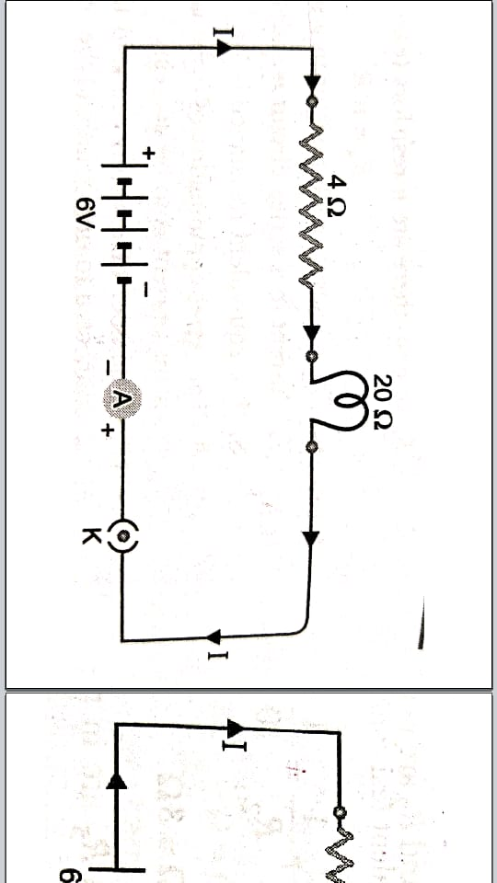

1. Suppose a 6 V battery is connected across a lamp whose resistance is 20 Ω through a variable resistor . If the current in the circuit is 0.25 A, calculate the value of the resistance from the resistor which must be used ?

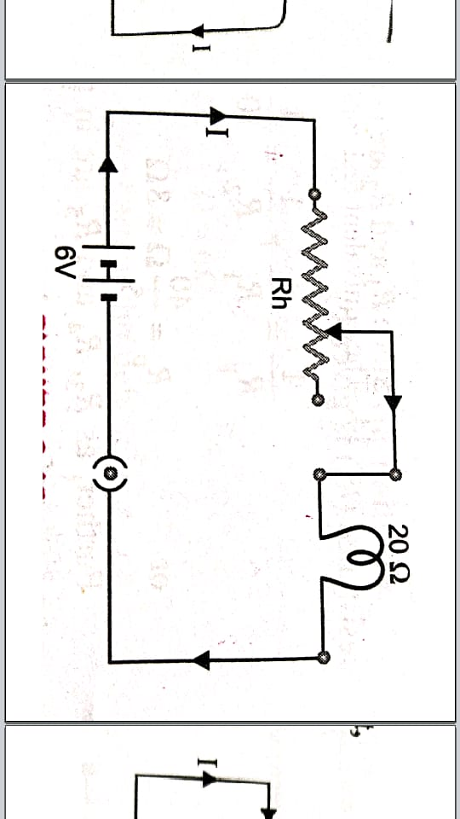

1. A 24 volt battery is connected to the arrangement of resistances as in figure. Calculate (i) the total effective resistance of the circuit, (ii) the total current flowing in the circuit.

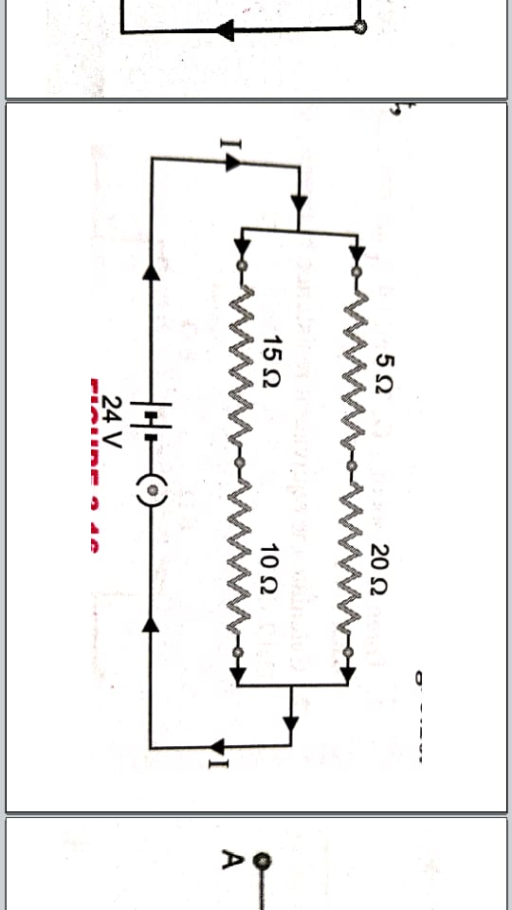

1. Three resistors of 6 Ω , 3 Ω and 2 Ω are connected together so that the total resistance is greater than 6 Ω but less than 8 Ω . Draw a diagram to show this arrangement and calculate its total resistance.

ELECTRICITY Page No. 3

1. Calculate the equivalent resistance between the points A and B in the circuits shown in figure.

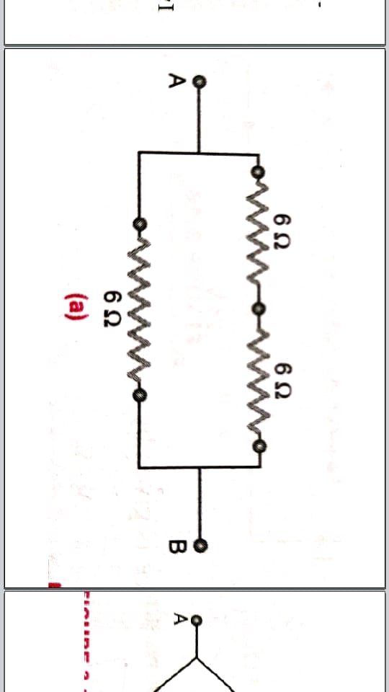 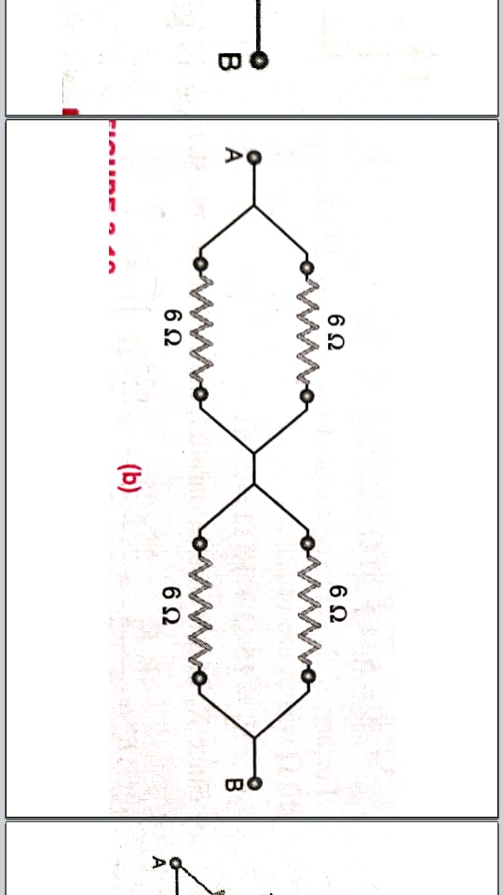

1. Three resistor of 2 Ω , 3 Ω and 4 Ω are connected in (a) series (b) parallel. Find the equivalent resistance in each case.
2. Three resistor each of 2 Ω are connected together so that their total resistance is 3 Ω . Draw a diagram to show this arrangement and check it by calculation.
3. A combination consists of three resistors in series. Four similar sets are connected in parallel. If the resistance of each resistor is 2 Ω , find the resistance of this combination .
4. A circuit consists of 1 Ω wire in series with a parallel arrangement of 6 Ω and 3 Ω wires. Calculate the total resistance of the circuit.
5. Calculate the effective resistances between the points A and B in the network shown in figure:

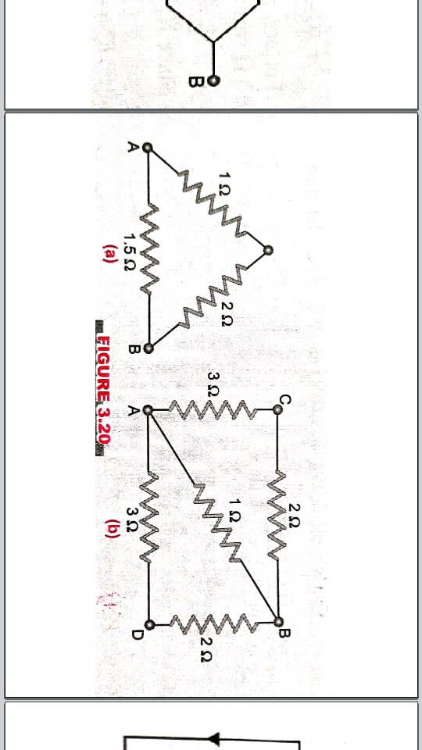

1. Two resistor 4 Ω and 6 Ω are connected in parallel. The combination is connected across a 6 V battery of negligible resistance. Calculate (a) the current through the battery (b) current through each resistor.
2. Carefully study the circuit diagram shown in figure and calculate the value of ‘x’.

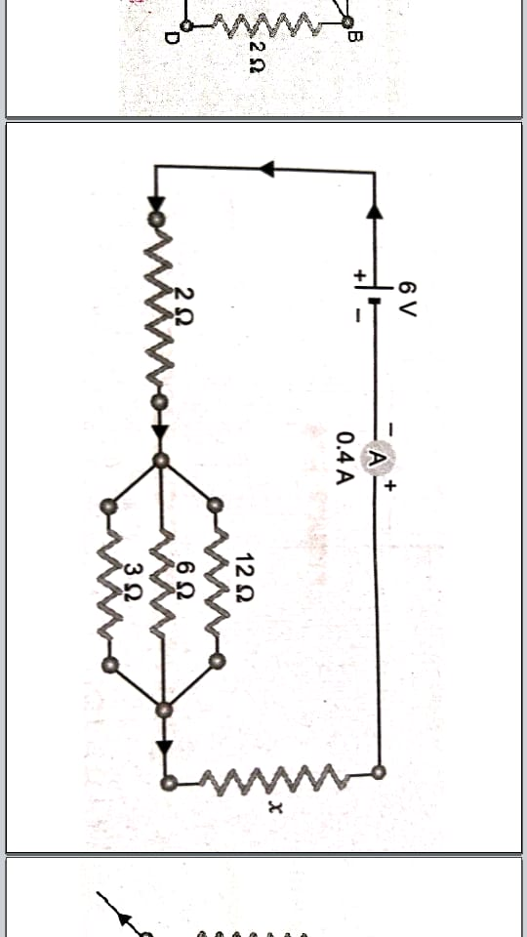

1. Three resistors of 6 Ω , 2 Ω and ‘x’ are connected in series to a cell of emf 1.5 V. The current registered is (1/6) A. Calculate the value of ‘x’.
2. A parallel combination of three resistors takes a current of 7.5 A from a 30 V supply. If the two resistors are 10 Ω and 12 Ω , find the third one.

ELECTRICITY Page No. 4

1. Calculate the equivalent resistance between the points A and B in the circuits shown in figure.

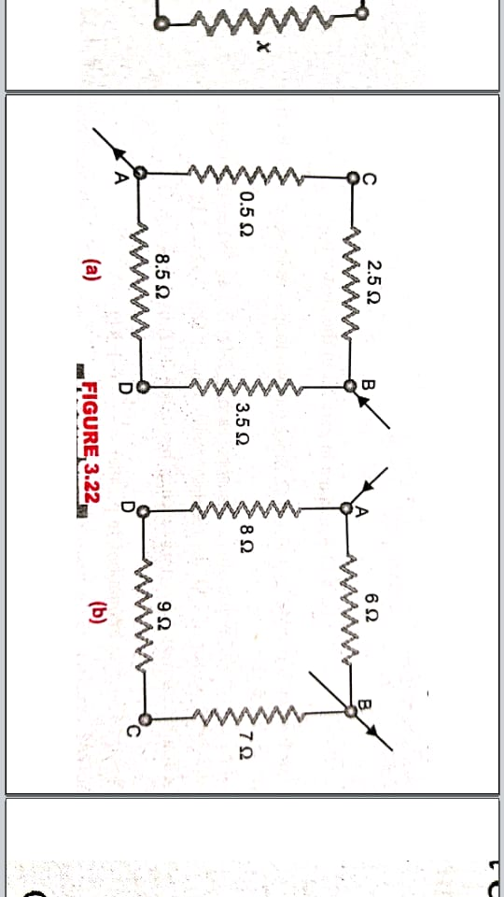

1. A wire whose resistance is 80 Ω is cut into three pieces of equal lengths which are then arranged in parallel. Calculate the resistance of the combination.
2. Five resistors, each 3 Ω , are connected as shown in figure. Calculate the resistance between the points (a) A and B (b) between the points C and D.

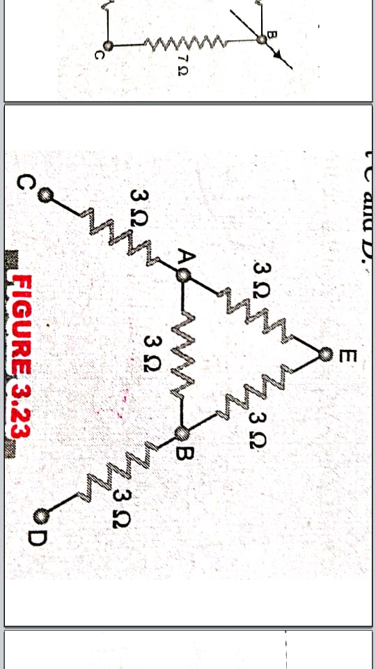

1. Calculate the equivalent resistance of the following network.

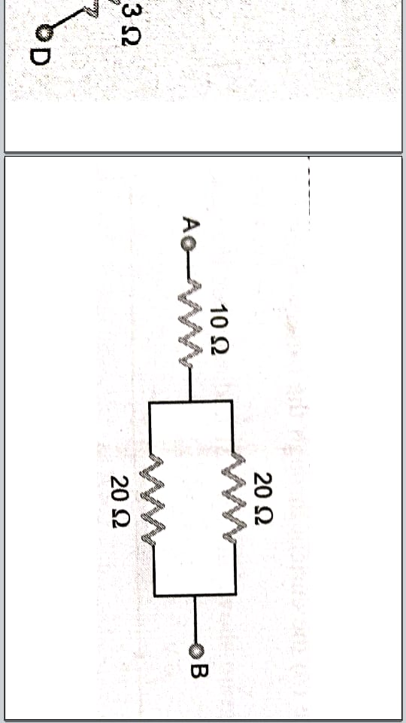

**Answers**

1. (i) 24 Ω (ii) 0.25 A (iii) 5 V , 1 V 2. 4 Ω 3. (i) 12.5 Ω (ii) 1.92 A 4. 7.2 Ω

5. (a) 4 Ω (b) 6 Ω 6. (a) 9 Ω (b) 0.92 Ω 7. In the diagram, show a parallel combination of two resistors of 2 Ω each and its combination in series with one resistor of 2 Ω 8. 1.5 Ω 9. 3 Ω

10. (a) 1 Ω (b) 0.71 Ω 11. (a) 2.5 A (b) 1.5 A , 1 A 12. 11.3 Ω 13. 1 Ω 14. 15 Ω

15. (a) 2.4 Ω (b) 4.8 Ω 16. 8.88 Ω 17. (a) 2 Ω (b) 8 Ω 18. 20 Ω

ELECTRICITY Page No. 5

**Karan Arora** **M:9416974837**

**Assignment – V**

1. An electric refrigerator rated at 400 W operates 8 hr/day. What is the cost of energy to operate it for 30 days at Rs. 3.00 per kWh ?
2. A torch bulb is rated at 2.5 V and 750 mA. Calculate its (i) power (ii) its resistance and (iii) the energy consumed if the bulb is lighted for 4 hour.
3. A 6 V – 12 W lamp is connected in series with a source of 12 V supply. Calculate the value of the resistance ‘R’ for the proper working of the lamp. What is the current flowing through the circuit ?
4. Two bulbs ‘A’ and ‘B’ are rated 100 W – 120 V and 10 W – 120 V respectively. They are connected across a 120 V source in series. Which will consume more energy ?
5. An electric bulb is connected to a 220 V generator. The current is 0.5 A. What is the power of the bulb ?
6. A torch bulb of 3 V draws a current of 0.4 A. If the bulb is switched on for 5 minutes. Calculate the energy released by the bulb.
7. An electric heater draws a current of 5 A and its element has a resistance of 50 Ω . If the heater is switched on for 5 minutes. Calculate the energy released in kilojoules.
8. An electric room heater has a resistance of 25 Ω and operates at 220 V at 12 minutes. Calculate heat energy dissipated by it in kilojoules.
9. Calculate the total power of 5 fans if each of them draws a current of 0.8 A at a potential difference of 220 V.
10. An electric bulb of resistance 400 Ω , draws a current of 0.5 A. Calculate the power of the bulb and the potential difference at its ends.
11. A soldering rod iron draws an energy of 45000 J in 4 minutes when the current flowing through its element is 6 A. Calculate the resistance of its heating element.
12. An electric bulb is marked 250 W – 200 V. What information does it convey? How many joules of energy is consumed by this bulb in one hour? How long will it take for the bulb to consume 1 kWh ?
13. Calculate the cost of running the following electrical devices in the month of September if the rate of 1 unit of electricity is Rs. 6.00.

(i) Electric heater of 1000 W for 5 hours daily (ii) Electric refrigerator of 400 W for 10 hours daily.

1. Two bulbs of 100 W each and 2 coolers of 250 W each, work on an average 6 hours a day. If the energy costs Rs. 1.75 per kWh, calculate the monthly bill and the minimum fuse rating when power is supplied at 250 V.
2. An electric kettle is rated at 230 V, 1000 W. What is the resistance of its element? What maximum current can pass through its element ?
3. Two bulbs ‘A’ and ‘B’ are rated 100 W – 120 V and 10 W – 120 V respectively. They are connected in parallel across a 120 V source. Find the current in each bulb. Which bulb will consume more energy ?

ELECTRICITY Page No. 6

1. Draw a circuit diagram of an electric circuit containing a cell , a key , an ammeter , a resistance of 4 Ω in series with a combination of two resistors (8 Ω) in parallel and a voltmeter across parallel combination. Each of them dissipate maximum energy and can withstand a maximum power of 16 W without melting. Find the maximum current that can flow through the three resistors.
2. A resistance of 10 Ω is bent in the form of a closed circle. What is the effective resistance between the two at the ends of any diameter of this circle ?
3. An electric geyser has the rating 2000 W – 220 V marked on it. What should be the minimum current rating (in whole number) of the fuse-wire to be used ?
4. Two resistors with resistances 10 Ω and 15 Ω are to be connected to a battery of emf 12 V so as to obtain: (i) minimum current (ii) maximum current. How will you connect the resistances in each case? Calculate the strength of the total current in the circuit in the two cases.
5. What is the safest voltage you can put across a 98 Ω – 0.5 W resistor ?
6. Two lamps one rated 100 W at 220 V and the other 200 W at 220 V are connected (i) in series (ii) in parallel to electric main supply of 220 V. Find the current drawn in each case.
7. A bulb is rated 40 W ; 220 V. Find the current drawn by it, when it is connected to a 220 V supply. Also find its resistance. If the given bulb is replaced by a bulb of 25 W ; 220 V, will there be any change in the value of current and resistance. Justify your answer and determine the change.

**Answers**

1. Rs. 288 2. 27000 J 3. 3 Ω 4. Bulb ‘B’ consumes more energy 5. 110 W 6. 360 J

7. 375 kJ 8. 1393.92 kJ 9. 880 W 10. 100 W , 200 V 11. 5.2 Ω 12. 900000 J , 4 h

13. Rs. 1620 14. Rs. 220.50 , 2.8 A 15. 52.9 Ω , 4.35 A 16. 0.83 A , 0.083 A , Bulb ‘A’

17. 2 A, 1 A, 1 A 18. 2.5 Ω 19. 10 A 20. 0.48 A , 2 A 21. 7 V 22. (i) 0.3 A (ii) 1.37 A

23. 1210 Ω ; 1936 Ω , 0.1818 A ; 0.1136 A

ELECTRICITY Page No. 7

**Karan Arora** **M:9416974837**

**COMPETITION FOCUS – 1**

1. A cell, a resistor, a key and an ammeter are arranged as shown in figure. The current recorded in the ammeter will be:

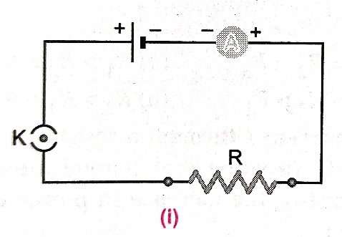 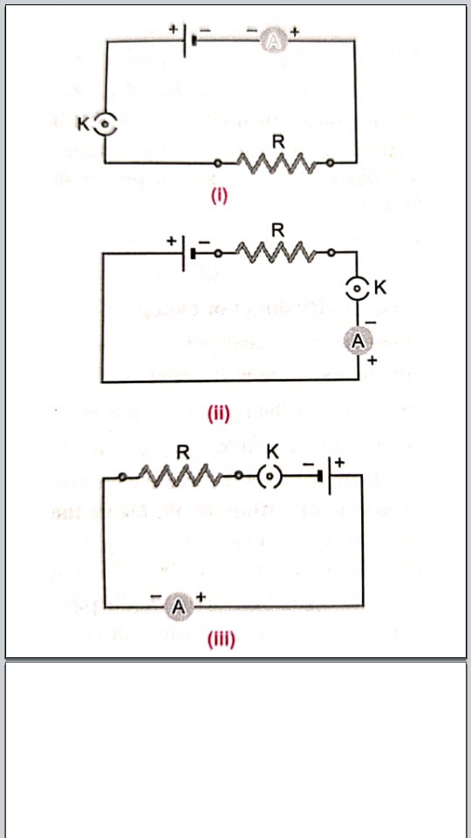 

|  |  |
| --- | --- |
| a) maximum in (i) | b) maximum in (ii) |
| c) maximum in (iii) | d) the same in all the cases |

1. In the following circuits as in figure, heat produced in the resistor or combination of resistor connected to a 12 V battery will be :

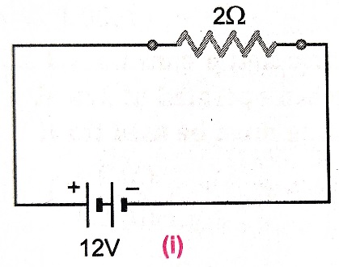 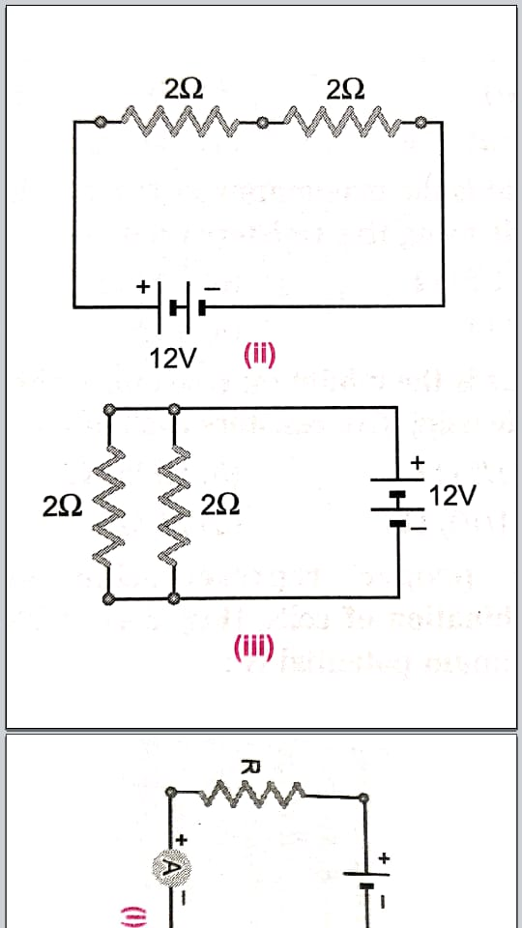 

|  |  |
| --- | --- |
| a) same in all the cases | b) minimum in case (i) |
| c) maximum in case (ii) | d) maximum in case (iii) |

1. Electrical resistivity of a given metallic wire depends upon :

|  |  |
| --- | --- |
| a) its length | b) its thickness |
| c) its shape | d) nature of the material |

1. A current of 1 A is drawn by a filament of an electric bulb. Number of electrons passing through a cross-section of the filament in 16 seconds would be roughly :

|  |  |  |  |
| --- | --- | --- | --- |
| a) 1020 | b) 1010 | c) 1018 | d) 1023 |

1. Identify the circuit in which the electrical components have been properly connected.

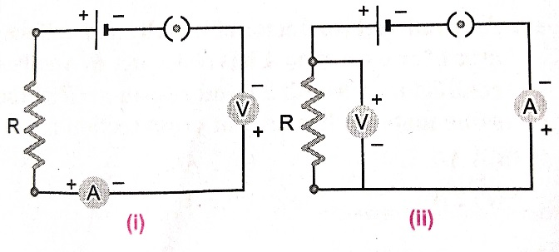 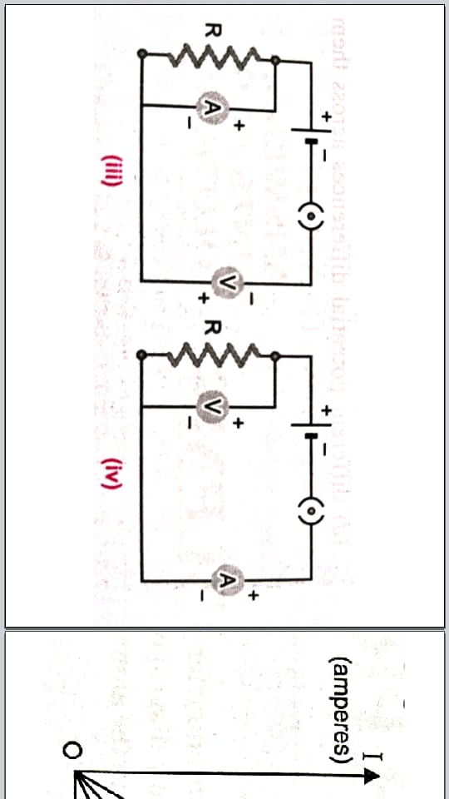

|  |  |  |  |
| --- | --- | --- | --- |
| a) (i) | b) (ii) | c) (iii) | d) (iv) |

ELECTRICITY Page No. 8

1. What is the maximum resistance which can be made using five resistors each of (1/5) Ω ?

|  |  |  |  |
| --- | --- | --- | --- |
| a) (1/5) Ω | b) 10 Ω | c) 5 Ω | d) 1 Ω |

1. What is the minimum resistance which can be made using five resistors each of (1/5) Ω ?

|  |  |  |  |
| --- | --- | --- | --- |
| a) (1/5) Ω | b) (1/25) Ω | c) (1/10) Ω | d) 25 Ω |

1. The proper representation of series combination of cells in figure, for obtaining maximum potential is :

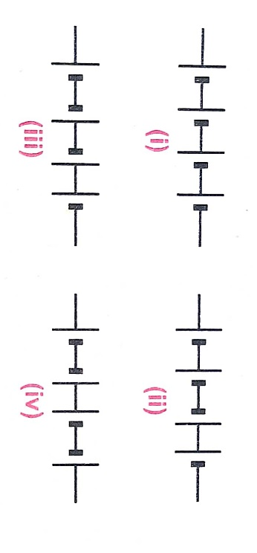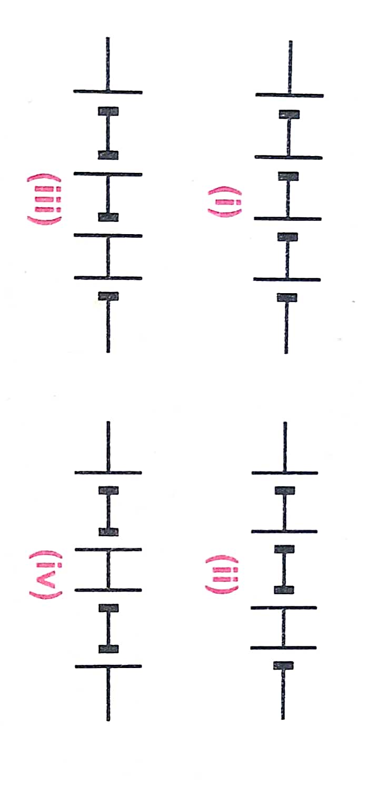

|  |  |  |  |
| --- | --- | --- | --- |
| a) (i) | b) (ii) | c) (iii) | d) (iv) |

1. Which of the following represents voltage ?

|  |  |
| --- | --- |
| a) | b) Work done x Charge |
| c) | d) Work done x Charge X Time |

1. A cylindrical conductor of length L and uniform area of cross-section A has resistance R. Another conductor of length 2 L and resistance R of the same material has area of cross section :

|  |  |  |  |
| --- | --- | --- | --- |
| a) A/2 | b) 3 A/2 | c) 2 A | d) 3 A |

1. A student carries out an experiment and plots the V-I graphs of three samples of nichrome wire with resistances R1 , R2 and R3 respectively, Which of the following is true ?

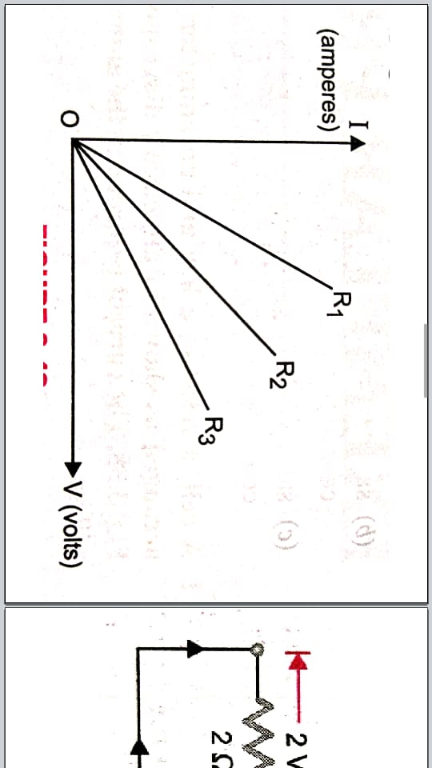

|  |  |  |  |
| --- | --- | --- | --- |
| a) R1 = R2 = R3 | b) R1 > R2 > R3 | c) R3 > R2 > R1 | d) R2 > R3 > R1 |

1. If the current I through a resistor is increased by 100 % (assumed that temperature remains unchanged), the increase in power dissipated will be :

|  |  |  |  |
| --- | --- | --- | --- |
| a) 100 % | b) 200 % | c) 300 % | d) 400 % |

1. The resistivity does not change if :

|  |  |
| --- | --- |
| a) the material is changed | b) the temperature is changed |
| c) the shape of the resistor is changed | d) both material and temperature are changed |

1. In an electrical circuit three incandescent bulbs A, B and C of rating 40 W, 60 W and 100 W respectively are connected in parallel to an electric source. Which of the following is likely to happen regarding their brightness ?

|  |  |
| --- | --- |
| a) Brightness of all the bulbs will be the same | b) Brightness of bulb A will be the maximum |
| c) Brightness of bulb B will be more than that of A. | d) Brightness of bulb C will be less than that of B |

1. In an electrical circuit, two resistors of 2 Ω and 4 Ω respectively are connected in series to a 6 V battery. The heat dissipated by the 4 Ω resistor in 5 s will be :

|  |  |  |  |
| --- | --- | --- | --- |
| a) 5 J | b) 10 J | c) 20 J | d) 30 J |

ELECTRICITY Page No. 9

1. Two resistor of resistance 2 Ω and 4 Ω when are connected to a battery will have :

a) same current flowing through them when connected in parallel.

b) same current flowing through them when connected in series.

c) same potential difference across them when connected in series

d) same potential differences across them when connected in parallel.

1. Unit of electric power may also be expressed as :

|  |  |  |  |
| --- | --- | --- | --- |
| a) volt ampere | b) Kilowatt hour | c) watt second | d) joule second |

1. An electric kettle consumes 1 kW of electric power when operated at 220 V. A fuse-wire of what rating must be used for it ?

|  |  |  |  |
| --- | --- | --- | --- |
| a) 1 A | b) 2 A | c) 4 A | d) 5 A |

**Answers**

|  |  |  |  |  |  |  |  |  |
| --- | --- | --- | --- | --- | --- | --- | --- | --- |
| 1. d | 2. d | 3. d | 4. a | 5. b | 6. d | 7. b | 8. a | 9. a |
| 10. c | 11. c | 12. c | 13. c | 14. c | 15. c | 16. b | 17. a | 18. d |

**COMPETITION FOCUS – 2**

1. When a 4 V battery is connected across an unknown resistor, there is a current of 100 mA in the circuit. The value of resistance is :

|  |  |  |  |
| --- | --- | --- | --- |
| a) 4 Ω | b) 40 Ω | c) 400 Ω | d) 0.4 Ω |

1. The resistivity of a conductor increases with :

|  |  |
| --- | --- |
| a) increase in temperature | b) increase in cross-sectional area |
| c) decrease in length | d) decrease in cross-sectional area |

1. Three copper wires have lengths and cross-sectional areas as (L , A) ; ( 2 L , A/2) and (L/2 , 2A). Resistance is minimum in

|  |  |
| --- | --- |
| a) wire of cross-sectional area A/2 | b) wire of cross-sectional area A |
| c) wire of cross-sectional area 2 A | d) same in all the three cases |

1. An electric bulb marked 40 W – 200 V is used in a circuit of supply voltage 100 V. Its power now is :

|  |  |  |  |
| --- | --- | --- | --- |
| a)100 W | b) 40 W | c) 20 W | d) 10 W |

1. When three identical bulbs of 60 W – 200 V rating are connected in series to a 200 V supply, the power drawn by them will be :

|  |  |  |  |
| --- | --- | --- | --- |
| a) 60 W | b) 180 W | c) 10 W | d) 20 W |

1. If two identical heaters, each rated 1000 W – 220 V ; are connected in parallel to 200 V; then the total power consumed is :

|  |  |  |  |
| --- | --- | --- | --- |
| a) 200 W | b) 2500 W | c) 250 W | d) 2000 W |

1. Which of the following statements does not represent Ohm’s law ?

|  |  |
| --- | --- |
| a) current/potential difference = constant | b) potential difference/current = constant |
| c) potential difference = current x resistance | d) current = potential difference x resistance |

1. If a wire is stretched to make its length three times, its resistance will become :

|  |  |  |  |
| --- | --- | --- | --- |
| a) 3 times | b) one-third | c) 9 times | d) one-tenth |

ELECTRICITY Page No. 10

1. In circuit, current becomes half when resistance is

|  |  |  |  |
| --- | --- | --- | --- |
| a) removed | b) doubled | c) halved | d) none of the above |

1. A number of cells when connected in series form :

|  |  |  |  |
| --- | --- | --- | --- |
| a) a generator | b) an inverter | c) a battery | d) battery eliminator |

1. Three resistances of 2 Ω , 4 Ω and 8 Ω are connected in series. Their equivalent resistance is :

|  |  |  |  |
| --- | --- | --- | --- |
| a) 10 Ω | b) (8/7) Ω | c) 14 Ω | d) between 2 Ω and 8 Ω |

1. A device is used to measure current , voltage and resistance is called :

|  |  |  |  |
| --- | --- | --- | --- |
| a) voltmeter | b) ammeter | c) AVO meter | d) ohm meter |

1. Three resistances of 2 Ω , 4 Ω and 8 Ω are connected in parallel. Their equivalent resistance is :

|  |  |  |  |
| --- | --- | --- | --- |
| a) 10 Ω | b) 14 Ω | c) (8/7) Ω | d) between 2 Ω and 8 Ω |

1. A wire of resistance 1 Ω is divide into two halves and both halves are connected in parallel. The new resistance will be :

|  |  |  |  |
| --- | --- | --- | --- |
| a) 1 Ω | b) 2 Ω | c) 0.5 Ω | d) 0.25 Ω |

1. In an electric circuit shown in figure, the pd across 4 Ω resistor is

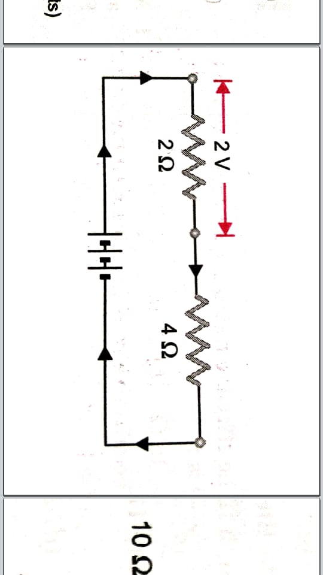

|  |  |  |  |
| --- | --- | --- | --- |
| a) 2 V | b) 4 V | c) 6 V | d) 8 V |

1. The pd across the terminals of the battery shown in above question figure.

|  |  |  |  |
| --- | --- | --- | --- |
| a) 4 V | b) 2 V | c) 8 V | d) 6 V |

1. Three resistors each of resistance 10 Ω , are connected as in figure. The equivalent resistance between the ends A and B is :

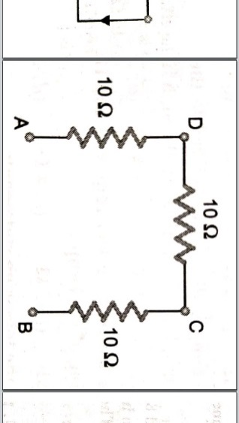

|  |  |  |  |
| --- | --- | --- | --- |
| a) 30 Ω | b) 20 Ω | c) 15 Ω | d) (10/3) Ω |

1. Two bulbs of 100 W and 40 W are connected in series. The current through the 100 W bulb is 1 A. The current through the 40 W bulb will be :

|  |  |  |  |
| --- | --- | --- | --- |
| a) 0.4 A | b) 0.6 A | c) 0.8 A | d) 1 A |

**Answers**

|  |  |  |  |  |  |  |  |  |
| --- | --- | --- | --- | --- | --- | --- | --- | --- |
| 1. b | 2. a | 3. c | 4. d | 5. d | 6. d | 7. d | 8. c | 9. b |
| 10. c | 11. c | 12. c | 13. c | 14. d | 15. b | 16. d | 17. a | 18. d |

ELECTRICITY Page No. 11

**Karan Arora** **M:9416974837**

**Paragraph Based Questions**

**Paragraph 1 :** Questions 1 to 5 are based on the electric circuit as in figure, through which a current of 1 A is flowing. Study the circuit and answers the following questions :

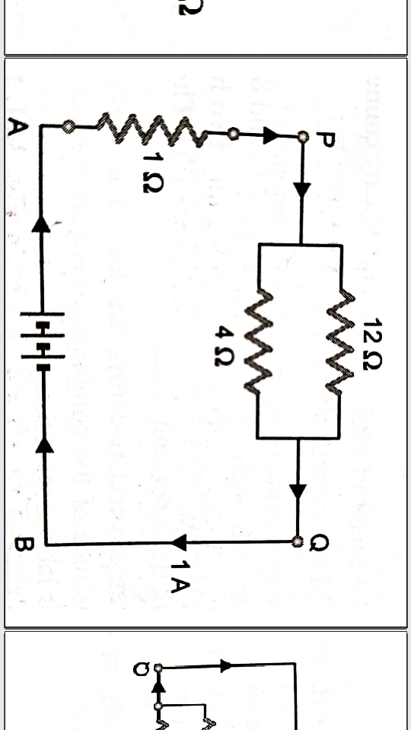

1. The effective resistance between the points P and Q is :

|  |  |  |  |
| --- | --- | --- | --- |
| a) 16 Ω | b) 12 Ω | c) 3 Ω | d) 4 Ω |

1. The effective resistance between the points A and B is :

|  |  |  |  |
| --- | --- | --- | --- |
| a) 1 Ω | b) zero Ω | c) 4 Ω | d) 3 Ω |

1. The pd across the battery terminals is :

|  |  |  |  |
| --- | --- | --- | --- |
| a) 5 V | b) 4 V | c) 13 V | d) 17 V |

1. Current flowing through resistance of 1 Ω is :

|  |  |  |  |
| --- | --- | --- | --- |
| a) 1 A | b) 0.75 A | c) 0.5 A | d) 0.25 A |

1. Read carefully the following statements regarding series combination of resistors.
2. The equivalent resistance is equal to the sum of individual resistances.
3. The current flowing through each resistor is the same.
4. The potential difference across each one of the resistors is the same.
5. The potential difference across any one of the resistors is directly proportional to its resistance.

Choose from the following which would be the correct statement (s).

|  |  |  |  |
| --- | --- | --- | --- |
| a) I and II | b) I , II and IV | c) Only III | d) II and IV |

**Paragraph 2 :** Questions 6 to 10 are based on electric circuit as in figure. Study the circuit and answer the following questions :

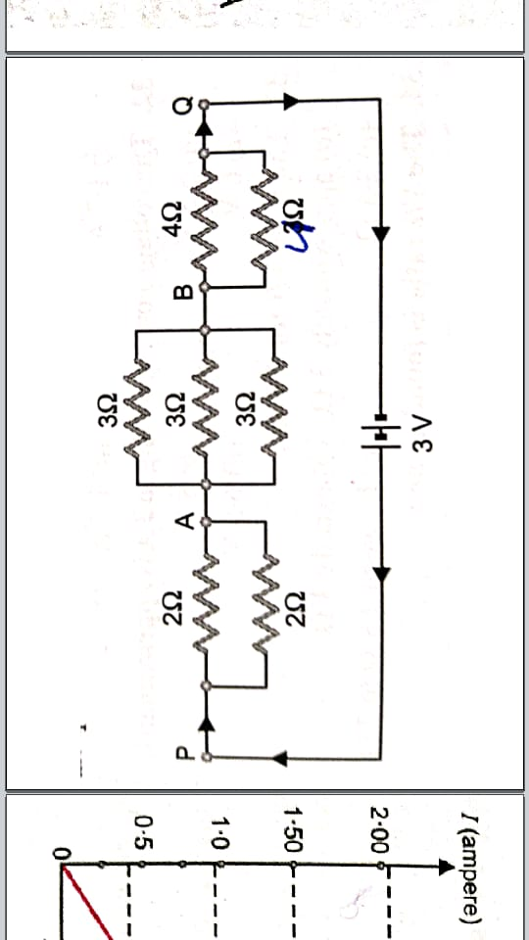

ELECTRICITY Page No. 12

1. The resistance between the points A and B is :

|  |  |  |  |
| --- | --- | --- | --- |
| a) 9 Ω | b) 3 Ω | c) 6 Ω | d) 1 Ω |

1. The resistance between the points P and Q is :

|  |  |  |  |
| --- | --- | --- | --- |
| a) 21 Ω | b) 4 Ω | c) 15 Ω | d) 9 Ω |

1. The current flowing in the circuit is :

|  |  |  |  |
| --- | --- | --- | --- |
| a) 3 A | b) 2 A | c) 1 A | d) 0.75 A |

1. The potential difference between the points A and B is :

|  |  |  |  |
| --- | --- | --- | --- |
| a) 0.75 V | b) 1.5 V | c) 2.25 V | d) 3 V |

1. Read carefully the following statements regarding parallel combination of resistors.
2. The reciprocal of the resultant resistance is equal to the sum of the reciprocals of the individuals resistances.
3. The potential difference across each resistor is the same.
4. A different current flows through each resistor.
5. The current through a resistor is directly proportional to its resistance.

Choose from the following which would be the incorrect statement (s).

|  |  |  |  |
| --- | --- | --- | --- |
| a) I and II | b) II and III | c) Only IV | d) III and IV |

**Paragraph 3 :** Questions 11 to 15 are based on performing an experiment to verify ohm’s law, a graph as in figure. Study the graph and answer the following questions :

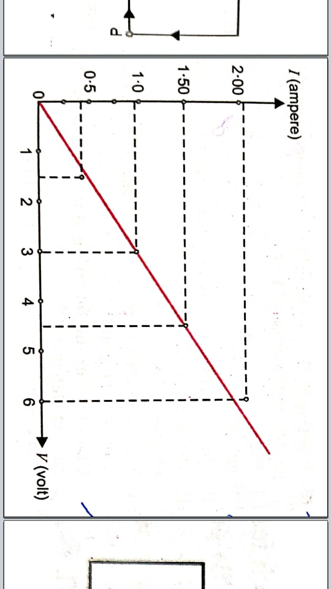

1. The current corresponding to 4.5 V is :

|  |  |  |  |
| --- | --- | --- | --- |
| a) 1.25 A | b) 1.5 A | c) 1.7 A | d) 1.4 A |

1. The voltage corresponding to 2 A is approximately :

|  |  |  |  |
| --- | --- | --- | --- |
| a) 5.5 V | b) 5 V | c) 6 V | d) 6.5 V |

1. The ratio V/I for 3 V is :

|  |  |  |  |
| --- | --- | --- | --- |
| a) approximately 3 Ω | b) exactly 3 Ω | c) 3.5 Ω | d) between 2.8 Ω to 3Ω |

1. The V/I ratio is found to be :

|  |  |  |  |
| --- | --- | --- | --- |
| a) around 2.5 Ω | b) around 3.5 Ω | c) around 3 Ω | d) around 2.8 Ω |

ELECTRICITY Page No. 13

1. Read carefully the following statements
2. Electrical resistance arises due to obstruction offered to the electron flow by the atoms in the conductor.
3. Resistance of a conductor depends on its length only.
4. Electrical potential is the condition which determines the direction of flow of charge.
5. A cell is used to provide potential difference across the terminals of an electric circuit.

Choose from the following which would be the correct statement (s).

|  |  |  |  |
| --- | --- | --- | --- |
| a) Only I and III | b) I , III and IV | c) Only III and IV | d) Only II |

**Paragraph 4 :** Questions 16 to 20 are based a 6 V – 12 W lamp is to be connected in a series with a 12 V supply as in figure. Study the circuit and answer the following questions :

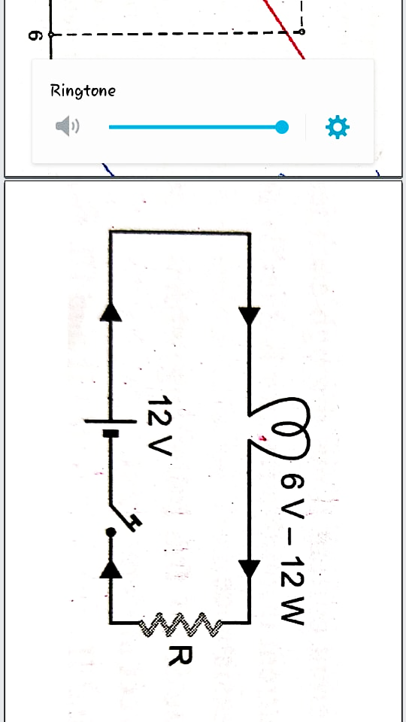

1. The current that can safely flow through the lamp is :

|  |  |  |  |
| --- | --- | --- | --- |
| a) 2 A | b) 1 A | c) 6 A | d) 3 A |

1. The resistance of the lamp (r) is :

|  |  |  |  |
| --- | --- | --- | --- |
| a) 6 Ω | b) 2 Ω | c) 3 Ω | d) 4 Ω |

1. If the lamp is directly connected to the source of 12 V supply, current flowing through it is :

|  |  |  |  |
| --- | --- | --- | --- |
| a) 6 A | b) 4 A | c) 3 A | d) 2 A |

1. Extra resistance (R) required for the proper working of the lamp :

|  |  |  |  |
| --- | --- | --- | --- |
| a) 6 Ω | b) 3 Ω | c) 4 Ω | d) 2 Ω |

1. Read carefully the following statements
2. The purpose of the extra resistance is to reduce the current to a safe value.
3. Total resistance in the circuit when the bulb is working properly is 6 Ω
4. Current flowing through the circuit when the bulb is working properly is 4 A.
5. Current flowing through the circuit when the bulb is safe is 2 A.

Choose from the following which would be the incorrect statement (s).

|  |  |  |  |
| --- | --- | --- | --- |
| a) Only II | b) I , III and IV | c) Only III | d) I and II |

**Answers**

|  |  |  |  |  |  |  |  |  |  |
| --- | --- | --- | --- | --- | --- | --- | --- | --- | --- |
| 1. c | 2. c | 3. b | 4. a | 5. b | 6. d | 7. b | 8. d | 9. a | 10. c |
| 11. b | 12. c | 13. a | 14. c | 15. b | 16. a | 17. c | 18. b | 19. b | 20. c |

ELECTRICITY Page No. 14

**Karan Arora** **M:9416974837**

**Fill in the Blanks**

1. The amount of charge that flows through a circuit carrying a circuit of 0.4 A for 3 h is ………………. .
2. Electric current is expressed by the amount of ……………………. flowing through a particular area in ………………. .
3. Potential difference between the points is equal to work done per unit ……………………… .
4. When several resistors are joined in series, the resistance of the combination equals to ………………………… of their ndividual resistances.
5. The total resistance in a parallel circuit ……………….. .
6. The alloy used for making the filament of a bulb is …………………… .
7. The resistance of a wire is ………………….. proportional to the square of its radius.
8. Two resistances of 2 Ω each are connected in parallel. The equivalent resistance is …………… .

**Answers**

1. 4320 C 2. Charge , unit time 3. Charge 4. Sum 5. Decreases 6. Tungsten

7. Inversely 8. 1 Ω

**True / False**

1. Three resistors of 2 Ω , 3 Ω and 6 Ω can be connected to give an equivalent resistance of 4 Ω
2. When 25 W and 100 W bulbs are connected in series, the 25 W bulb glows brighter.
3. At constant voltage, the heat developed in a uniform wire varies inversely as the length of the wire used.
4. Pure tungsten has high resistivity and a high melting point.
5. When two resistors of 1 Ω and 3 Ω are connected in parallel, their equivalent resistance is less than 1 Ω.
6. Electric current flows in a direction opposite to the flows of electrons.

**Answers**

|  |  |  |  |  |  |
| --- | --- | --- | --- | --- | --- |
| 1. True | 2. True | 3. True | 4. True | 5. True | 6. True |

**Matching Type Question**

1. Column I Column II

|  |  |
| --- | --- |
| (A) Filament of electric bulb | (p) Copper |
| (B) Heating element | (q) Lead – tin alloy |
| (C) Connecting wire | (r) Tungsten |
| (D) Fuse wire | (s) Nichrome |

**Answer :** A → (r) , B → (s) , C → (p) , D → (q)

ELECTRICITY Page No. 15

**Karan Arora** **M:9416974837**

**Assertion-Reason Type Questions**

**DIRECTIONS :** In each of the following questions, a statement of Assertion (A) is given followed by a corresponding statement of Reason (R) just below it. Of the statements, mark the correct answer as:

1. If both assertion and reason are true, but reason is the true explanation of the assertion.
2. If both assertion and reason are true, but reason is not the true explanation of the assertion.
3. If assertion is true, but reason is false.
4. If assertion is false, but reason is true.
5. **Assertion:** A fused wire is always connected in parallel with the main line.

**Reason:** If a current larger than the specified value flows through the circuit, fuse wire melts.

1. **Assertion:** As soon as a source of emf is connected across a conductor, the current immediately starts flowing through it.

**Reason:** Drift speed of electrons is so large that electrons travel from one end of the conductor to the other almost instantaneously.

1. **Assertion:** A 60 W – 20 V bulb glows more than a 100 W – 220 V bulb when they are connected in series across a potential difference.

**Reason:** When they are connected in series, resistance of 100 W bulb will be more.

1. **Assertion:** When the length of a wire is doubled, its resistance also gets doubled.

**Reason:** The resistance of a wire is directly proportional to its length.

1. **Assertion:** Silver is not used to make electric wires.

**Reason:** Silver is a bad conductor.

**Answers**

|  |  |  |  |  |
| --- | --- | --- | --- | --- |
| 1. d | 2. c | 3. c | 4. a | 5. c |

ELECTRICITY Page No. 16